**Team: Techno-Boys**

**No Mask No Entry**

**Objective:**

To create a face mask detector Door opener using Machine Learning.

**Table1: Required components**

|  |  |  |  |  |  |
| --- | --- | --- | --- | --- | --- |
| **S.**No**.** | **Name** | **Quantity** | **Technical-Speciality** | **Cost** | **Usage** |
| **1** | Arduino Uno | 1 | Arduino Uno is a micrometer board based on the ATmega328P.It has 14 digital pins, 6 analog inputs | 770 | Arduino UNO acts as the main controlling part |
| **2** | PIR Sensor | 1 | The PIR Motion sensor module is an automatic control module based on infrared technology.. | 159 | Detecting human motion is done with the help of PIR Sensor |
| **3** | L298N Motor Driver Module | 1 | L298N Motor Driver Module is a high power motor driver module for driving DC and Stepper motors. | 303 | It is responsible for driving the motor of the door |
| **4** | CD Tray with 5V Motor | 1 | It consists of 5V motor and can work up to 12V power supply. | 200(app.) | Work as a Door |
| **5** | Breadboard | 1 | Breadboard consists of grid of contacts with contacts typically spaced one-tenth of an inch apart. | 215 | To build and test circuits quickly before finalizing any circuit design |
| **6** | Connecting Wires | 10 | It allows electric current to travel from one point on a circuit to another. | 115 | To connect the devices |
| **7** | Power Supply up to 12volts | 1 | It supplies power to the circuit. | 1000 | Provides the power supply |
| **8** | 5 Push Buttons | 2 | Mode of Operation: Tactile Rating: MAX 50mA 24V DC, , | 20 |  |
| **9** | 5MP Camera | 1 | Up to 1920*1080 high resolution, 1/2.7”. | 1000 | To record and train the system |

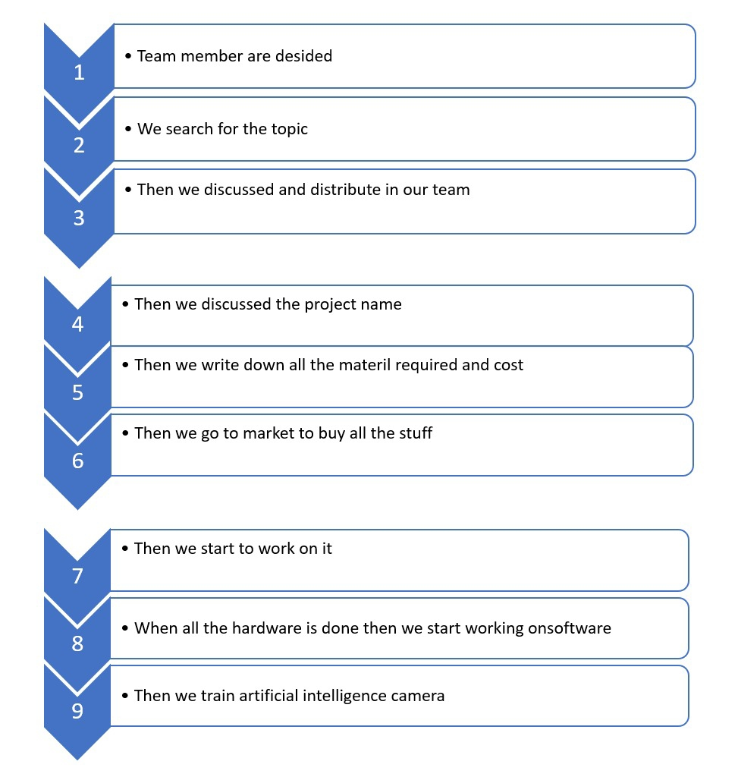

**Figure1: Flow Chart**

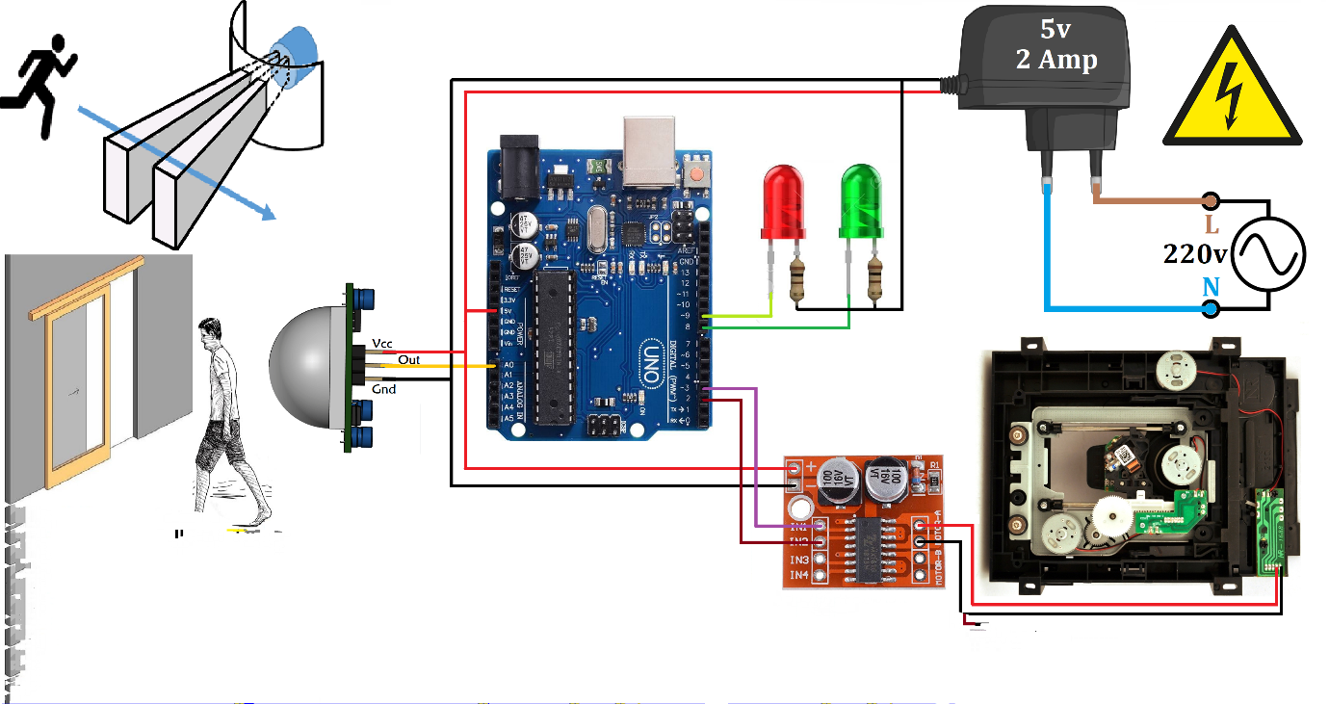

**Figure2: Schematic Diagram**

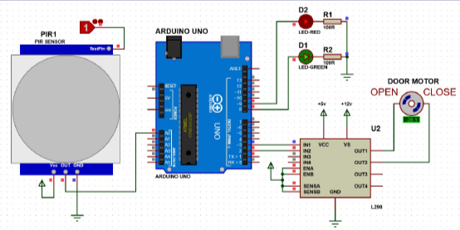

**Figure3: Circuit Diagram**

**Team Members:**

1. Udit Kumar Sharma
2. Taaran Jain
3. Tanishq Soni
4. Vikas Sharma

**Refrences:**

* <https://en.wikipedia.org/wiki/Automatic_door>
* <https://www.electronicshub.org/automatic-door-opener-using-arduino/>
* <https://create.arduino.cc/projecthub/embeddedlab786/automatic-door-opening-system-d9ea30>
* <https://openscholarship.wustl.edu/cgi/viewcontent.cgi?article=1102&context=mems411>
* <https://www.britannica.com/technology/artificial-intelligence#:~:text=Artificial%20intelligence%20(AI)%20is%20the,require%20human%20intelligence%20and%20discernment>.
* <https://en.wikipedia.org/wiki/Machine_learning#:~:text=Machine%20learning%20(ML)%20is%20the,by%20the%20use%20of%20data.&text=Machine%20learning%20algorithms%20build%20a,explicitly%20programmed%20to%20do%20so>.